Guvi Jira Task 2

Epic 1 - <https://gopikrishnas473.atlassian.net/browse/PMTJ-1>

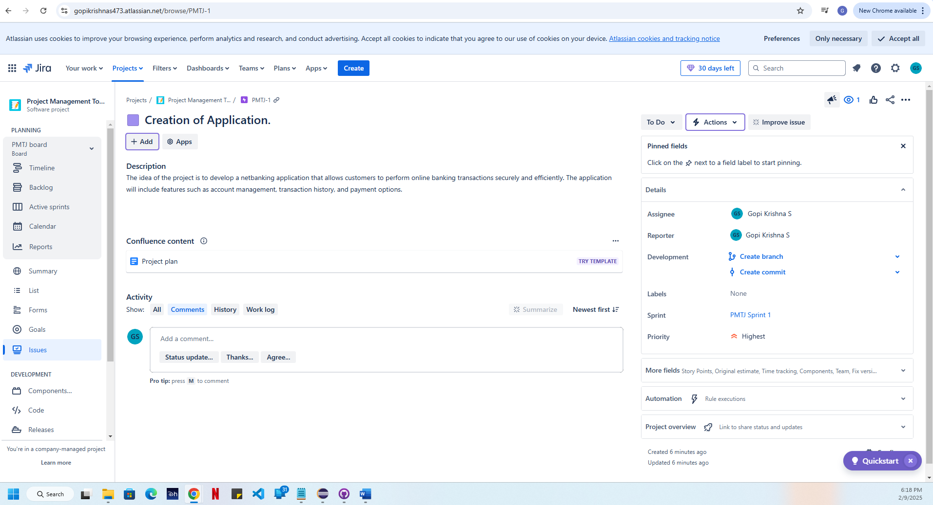  
  
Epic 2 - <https://gopikrishnas473.atlassian.net/browse/PMTJ-2>  
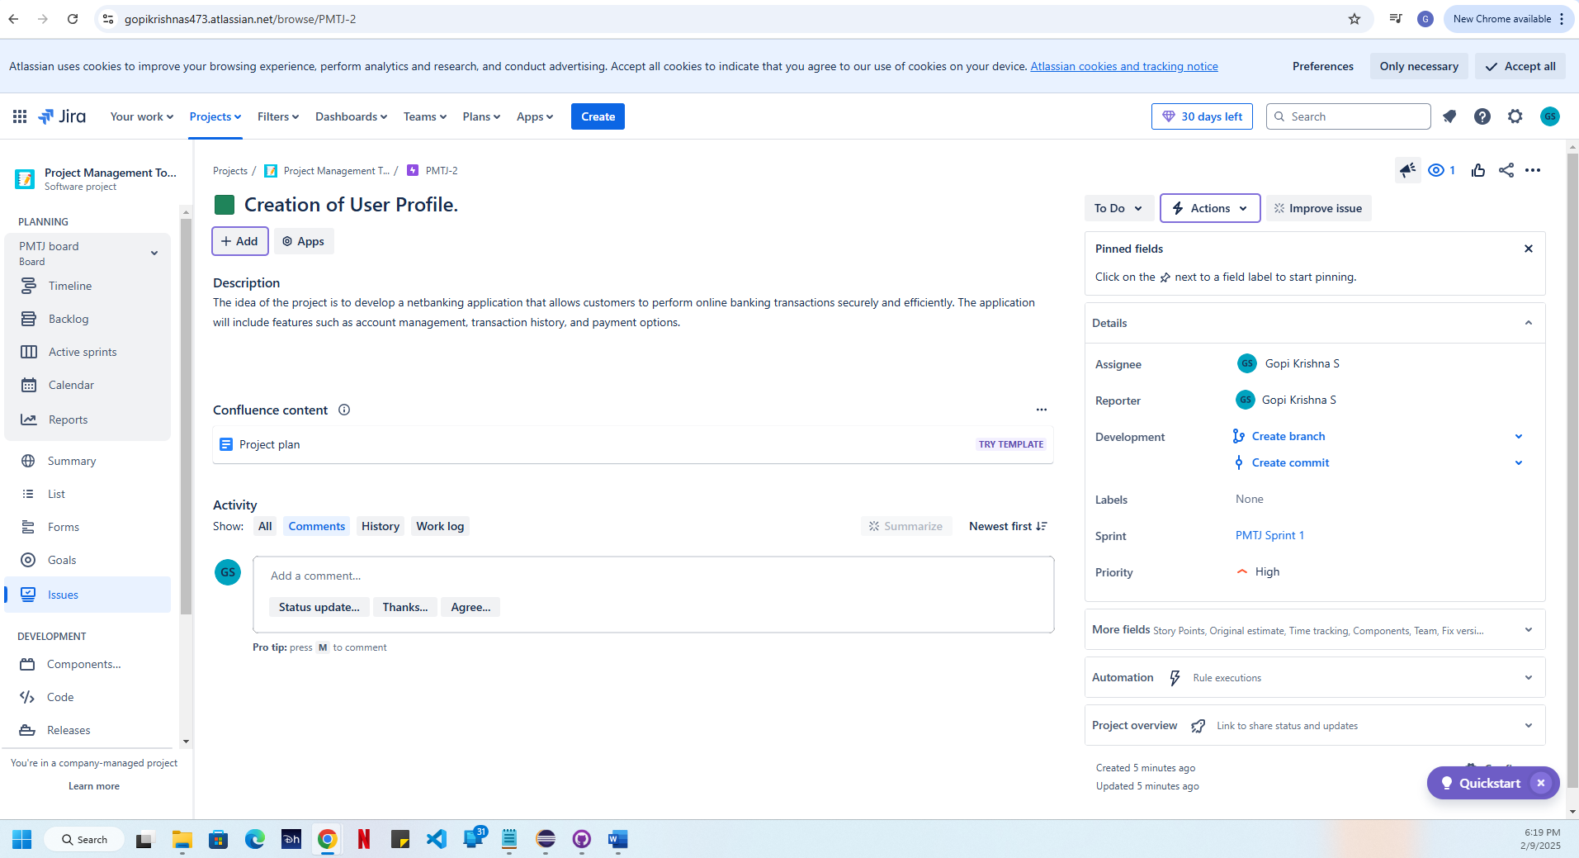  
Epic 3 - <https://gopikrishnas473.atlassian.net/browse/PMTJ-3>  
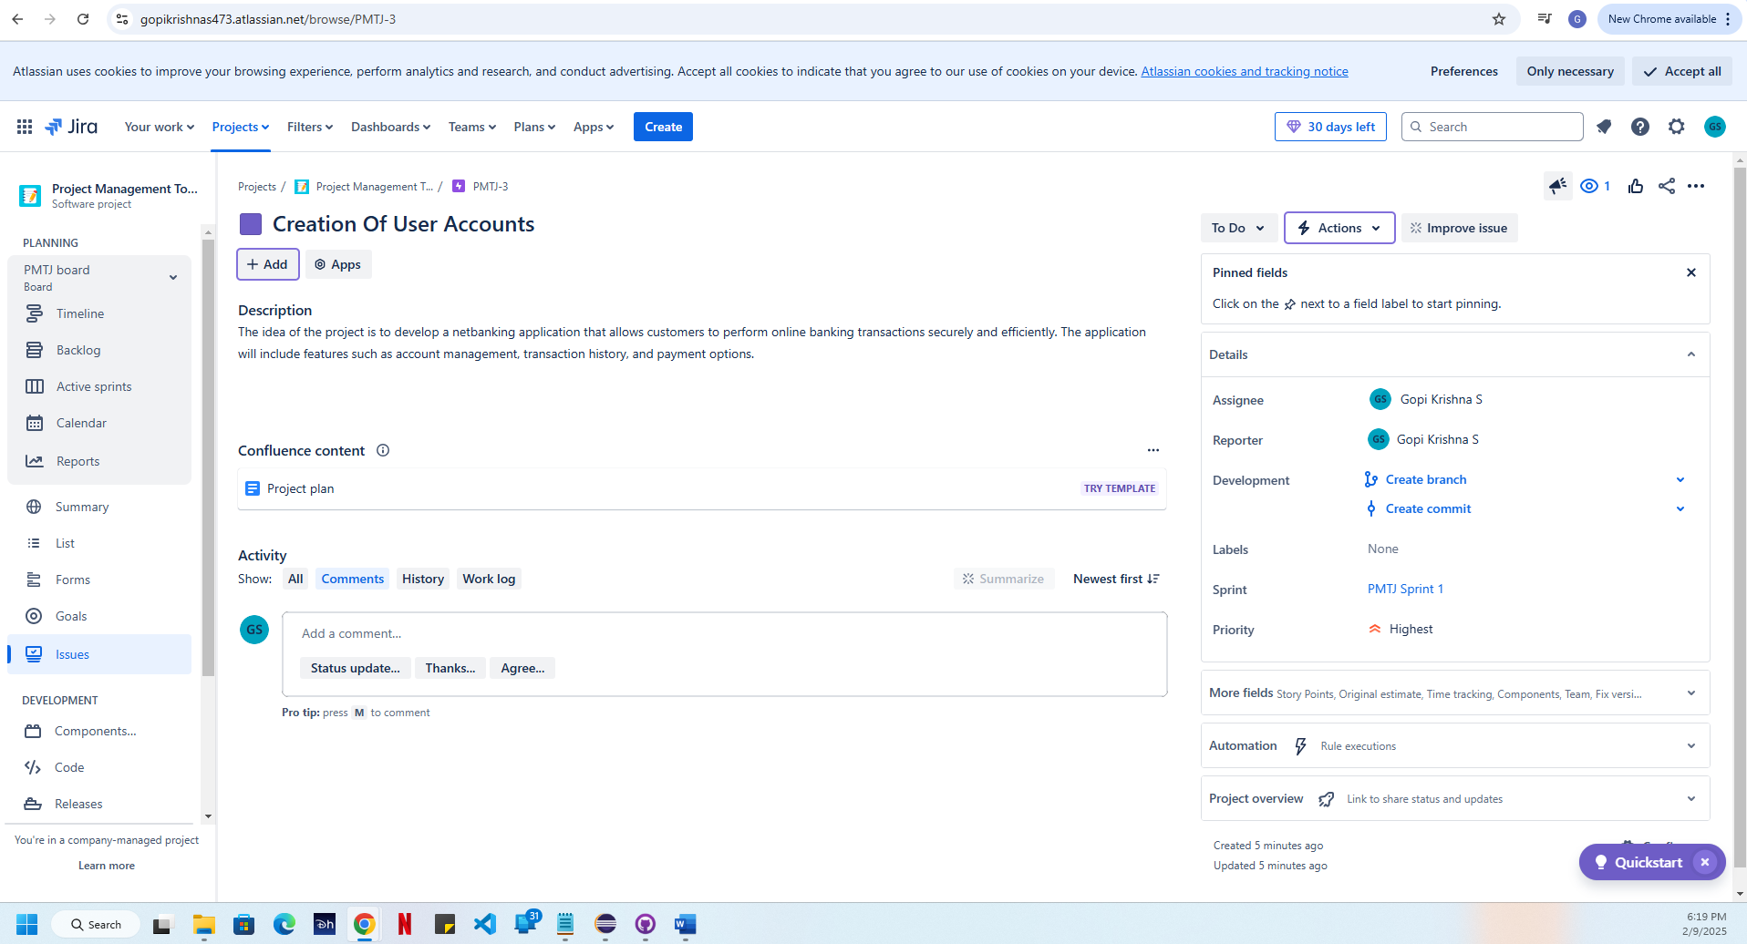  
Epic 4 - <https://gopikrishnas473.atlassian.net/browse/PMTJ-4>  
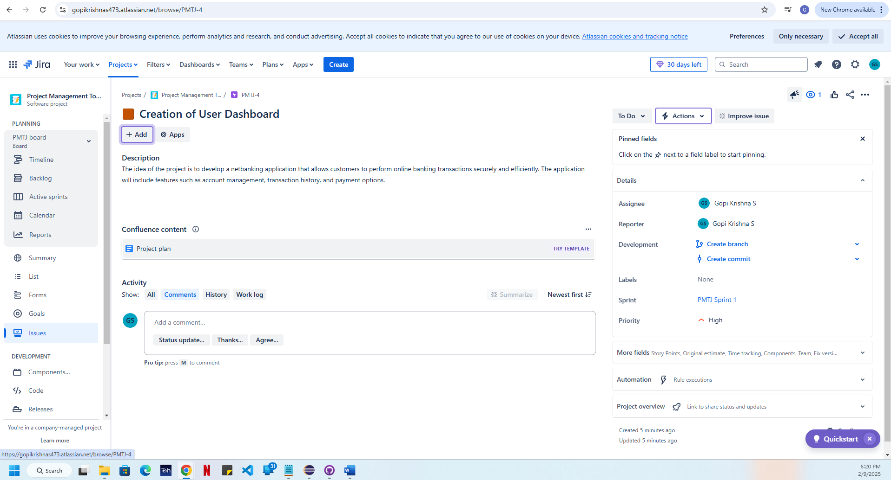  
Epic 5 - <https://gopikrishnas473.atlassian.net/browse/PMTJ-5>  
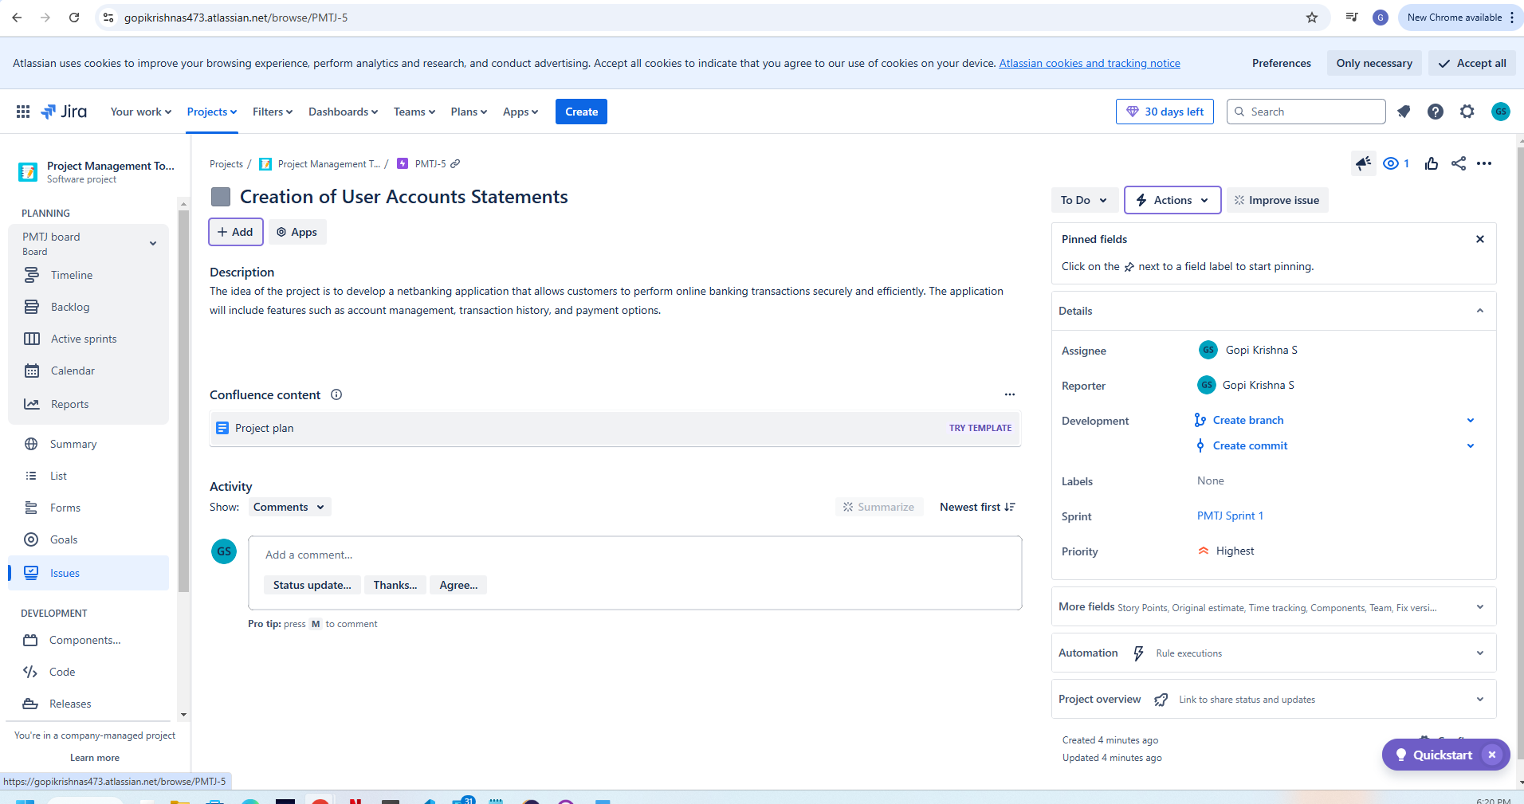  
  
User Stories - <https://gopikrishnas473.atlassian.net/browse/PMTJ-1>  
  
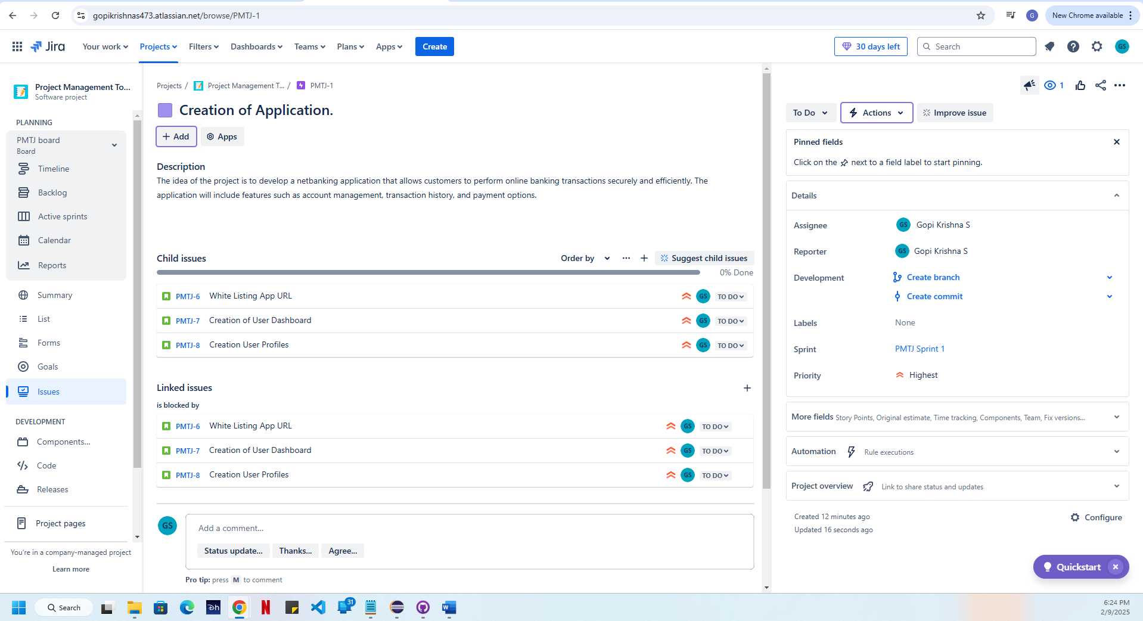  
Backlog Creation - 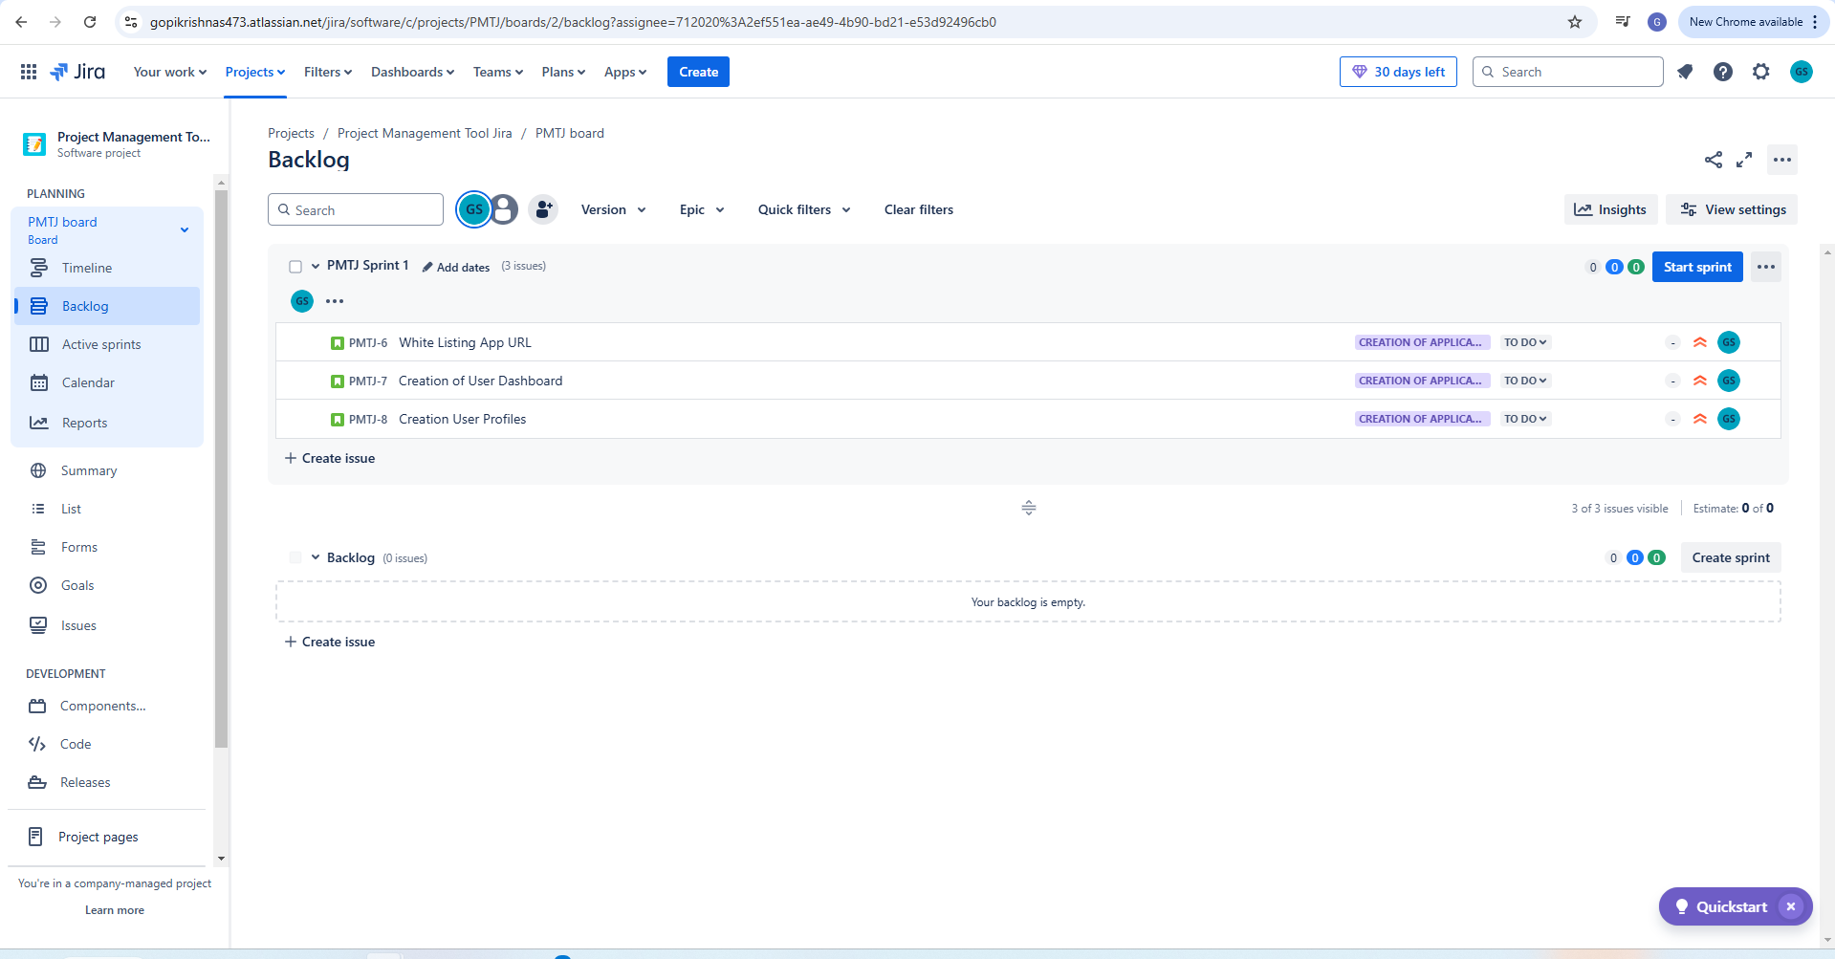  
Sprint Planning - 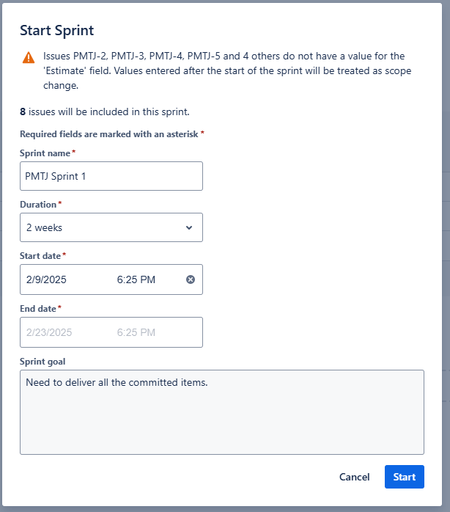  
Sprint Execution - 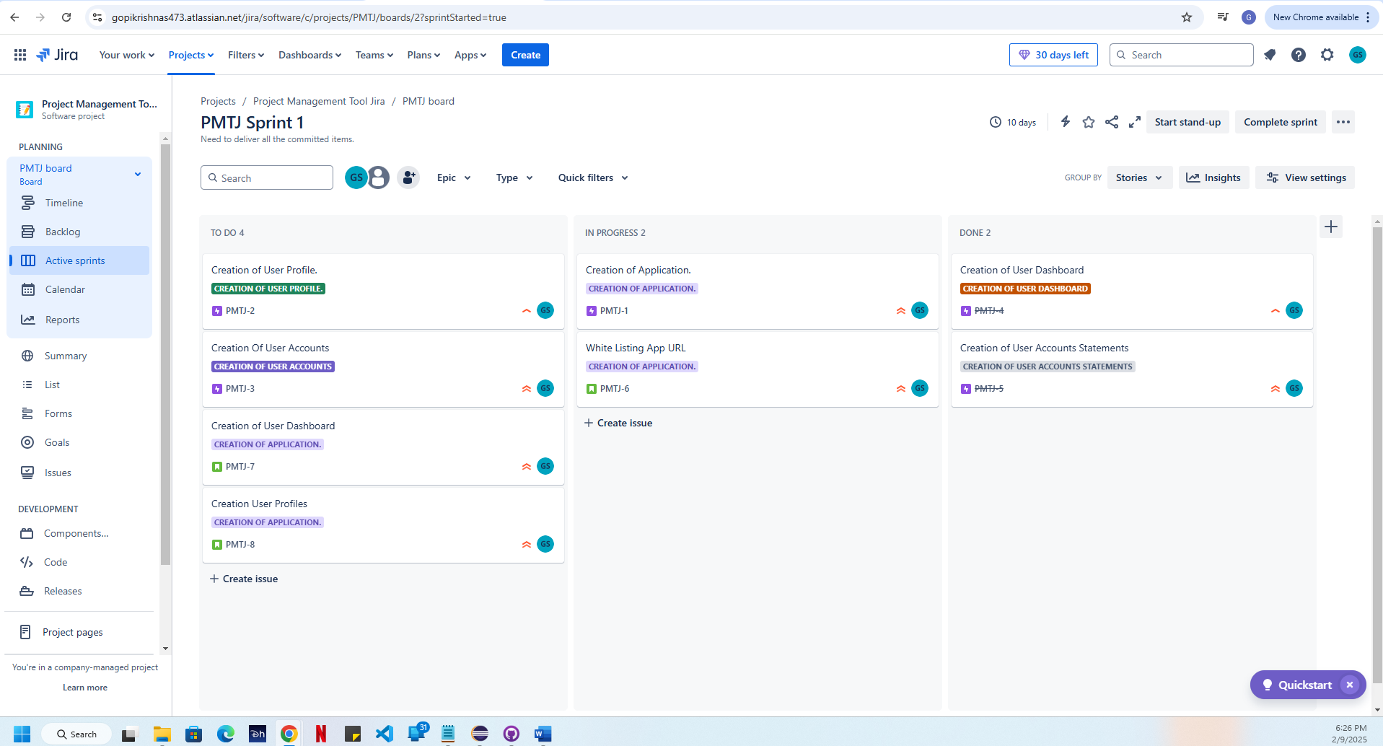  
  
Sprint Report - 